**Round 2**

### Experiment: Proell Governor

**1. Story Outline:**

Governors, in general, are most useful means of controlling or regulating the speed of an engine based on varying levels of the load at the output. They are used in regulating the speed of the engine, which takes to the fact that the fuel injected is based on the speed variations seen along the shafts.[1]

Proell governor is a type of gravity controlled [centrifugal governor](http://www.mecholic.com/2016/12/types-of-governor-centrifugal-inertia.html#Centrifugal_governor). The centrifugal governor works on the principle of centrifugal force, which gets applicable on the rotating balls. These balls are known as fly balls, which are attached to the spindle through links. The balls rotate with a spindle which is rotated by the engine through a bevel gear. The upper ends of the arms are pivoted to the spindle, so that the balls may rise up or fall down as they revolve about the vertical axis. The arms are connected by the links to a sleeve, which is keyed to the spindle. This sleeve revolves with the spindle; but can slide up and down. The balls and the sleeve rise when the spindle speed increases, and falls when the speed decreases. This controls the throttle valve thus regulating the fuel intake of the engine, hence controlling the speed. In Proell governor, fly balls are attached to the upward extension of the link and central load attached to the sleeve.[2]

**2. Story:**

**2.1 Set the visual stage description:**

The experiment consists of Proell governor in Front view and Top view bothon the left-hand side of the simulator, a free-body diagram is shown in the middle top corner, Rotational speed can be controlled by a slider knob and graph can be obtained by clicking on the check box.

Front view consists of four links represented in blue colour, Top sleeve represented in purple colour, bottom sleeve represented in yellow colour, fly balls represented in brown colour and shaft in green colour.

In front view, Top sleeve and bottom sleeve are along a single vertical axis. Longer link, shorter link and fly ball form one pair. Longer link is at an acute angle from the vertical axis. One end of longer link is connected to bottom sleeve and the other end has fly ball. One end of shorter link is connected to longer link just below the fly ball and the other end to top sleeve. The other pair of shorter link and longer link is connected diametrically opposite to the first pair in the sleeves. Bottom sleeve, central load and shaft form one assembly which slides up and down depending on input rotational speed. The whole assembly rotates along the vertical axis.

In Top View visualisation, top sleeve is located above the front view in the same vertical axis. It rotates at this fixed location. Shorter and longer link are represented by a straight line, one end connected to top sleeve other end connected to fly ball. The other pair is connected diametrically opposite to the first pair in the top sleeve. By varying the input rotational speed, diameter of circle formed by fly balls changes.

A graph is plotted indicating relationship between height of governor to rotational speed.

**2.2 Set User Objectives & Goals:**

* Identify the differences between hartnel governor, porter governor and proell governor.
* Identify different parts of Proell governor.
* Understand its working and uses.
* Analyze the forces acting on different parts of Proell governor.
* Analyze theoretical correlation and graphical correlation of change in height of the governor due to change in rotational speed.
* Visualise and observe the change in height of governor due to change in rotational speed in Front View.
* Visualise and observe the change in diameter of the circle formed by fly balls due to change in rotational speed in Top view.
* Attempt the assessment questions.

**2.3 Set the pathway activities:**

1. The input rotational speed initially is set at 100 rpm.
2. The initial height of bottom sleeve is noted down in Front view.
3. The initial diameter of the circle formed by fly balls is noted down in Top view.
4. The checkbox of graph is clicked.
5. The input rotational speed is varied from 100 rpm to 150 rpm using knob slider.
6. The input rotational speed can also be varied from 100 rpm to 150 rpm using Numeric control.
7. The change in height of the governor due to change in rotational speed in Front view is noted down.
8. The change in diameter of circle formed by fly balls due to change in rotational speed in Top view is noted down.
9. The theoretical correlation and graphical correlation of change in height of the governor due to change in rotational speed is noted down.

**2.4 Set Challenges and Questions/Complexity/variation**

1) Which among these is a pendulum type governor

1. Inertia governor
2. Watt governor
3. Porter governor
4. Proell governor

2) Which component control "variation of speed each cycle of the engine"?

1. Governor
2. Flywheel
3. Accelerator
4. Carburettor

3) Lightest fly balls used among these in

1. Watt governor
2. Porter governor
3. Proell governor
4. Equal weight in all

4) Which one of the following is a Dead weight type governor?

1. Porter Governor
2. Hartnell Governor
3. Wilson-Hartnell Governor
4. Hartung Governor

5) The height of a governor is distance measure from

1. the centre of two balls mass
2. the centre of balls mass to the point of intersection of upper arms
3. the centre of balls mass to the point of intersection of  lower links
4. the point of intersection of upper arms to the point of intersection of  lower links

6)  Which of the following Governor is not suitable for High speeds

1. Watt
2. Hartnell
3. Wilson Hartnell
4. Hartong

7) The ratio of the height of porter governor (when the length of arms and links are equal) to the height of watt governor is (Where m is the mass of the ball and M is the mass of sleeve)

1. (m+M)/m
2. M/(m+M)
3. m/(m+M)
4. None of the above

8) Which type of governor is used in a petrol engine?

1. Pendulum type
2. Spring load type
3. Inertia type
4. Any of the above
5. SI engine doesn't have a governor

9) Governor is attached to the camshaft through

1. Bevel gear
2. Spur gear
3. Rack and pinion
4. Herringbone gear

10) Which of the following is more appropriate if we remove the governor:

1. The engine wouldn't work at all
2. We Can't control the speed limit
3. It will take more fuel for the same distance
4. None of these

11) What is the theoretical correlation between speed and height of the governor?

1)

2)

3)

4)

12) The arms of proell governor are 300 mm long. The pivots of upper and lower arm are 30 mm from the axis. The load on the sleeve is 250N and weight of each ball is 30N. When the governor sleeve is at mid position the extension link of the lower arm is vertical and radius of rotation of the balls is 160 mm. The vertical height of governor is 200 mm. If speed of governor at mid-position is 150 rpm, find the length of extension link.

1) 502mm

2) 232 mm

3) 270 mm

4) 320 mm

13) Which of the following statement is TRUE

1) The same equilibrium speed for m, M and H ball of smaller masses can be used in Proell governor compare to Porter governor.

2) The same equilibrium speed for m, M and H ball of larger masses can be used in Proell governor compare to Porter governor.

3) The same equilibrium speed for m, M and H ball of same masses can be used in Proell governor compare to Porter governor.

4) None of the above

14) From the simulator, at 128 rpm what is the approximate height of the governor

1) 120 mm

2) 160 mm

3) 200 mm

4) 240 mm

15) If height of the governor increases speed

1) decreases

2) increases

3) remains constant

4) none of above

16) Identify these parts of the proell governor

  

1) Fly ball, Link, top sleeve

2) Central load, bottom sleeve, top sleeve

3) Central load, bottom sleeve, top sleeve

4) Fly ball, Link, bottom sleeve

**Answer:** Fly ball, Link, bottom sleeve

17) Identify these parts of the proell governor



1) Link, top sleeve

2) Central load, bottom sleeve

3) Central load, top sleeve

4) Top sleeve, bottom sleeve

**Answer:** Central load, top sleeve

**2.5 Allow pitfalls: NA**

**2.6 Conclusion:**

Time required to perform the virtual experiment.

The approximate time required to understand the procedure to perform the experiment would take about 5 min. The time required to understand the change in height of the shaft due to change in rotational speed in Front view and top view is 5 min. The time required to understand the theoretical correlation and graphical correlation after checking the graph checkbox is 5 min. Thus, the total time required to perform the experiment will require around 15 min.

**2.7 Equations/formulas:**

**Mathematical equation:**

*m* = Mass of each ball (kg)

*W* = Weight of each ball = m*g (N)

*M* = Mass of central load (N)

*r* = Radius of rotation (m)

*h* = Height of governor (m)

*ω* = Angular speed of the ball in (rad/s)

*Fc* = Centrifugal force acting on the ball (N)

*T1* = Tension in the arm (N)

*T2* = Tension in the link (N)

*α* = Angle of inclination of the arm (rad)

*β* = Angle of inclination of the link (rad)

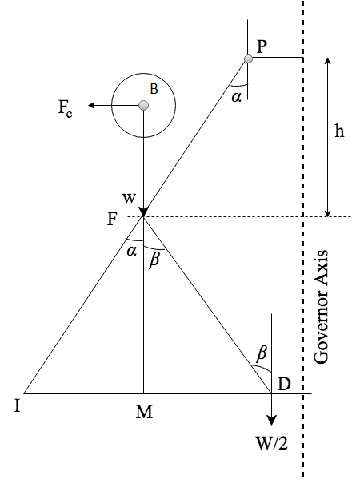

By considering the equilibrium force for half of the governor referring above figure. The instantaneous centre (I) lies on an extension of PF and MD in a leftward direction. BM is drawn a perpendicular to the ID. If we take a moment of inertia through I,

$$F_{c}×BM=w×IM+\frac{W}{2}×ID=mg×IM+\frac{Mg}{2}ID$$

$F_{c}=mg×\frac{IM}{BM}+\frac{Mg}{2}\left(\frac{IM+MP}{BM}\right)$......................... (1)

Where, [ID = IM+MD]

Multiplying and dividing both sides by FM we get,

Fc = $\frac{FM}{BM}\left[m*g*\frac{IM}{FM} + \frac{M*g }{2}(\frac{IM}{FM}+\frac{MP}{FM})\right]$

Fc = $\frac{FM}{BM}$ [m*g $tanα$* + $\frac{M*g }{2}$ ($tanα+tanβ$)]

Fc = $\frac{FM}{BM}* tanα$ [m*g + $\frac{M*g }{2}$ ($1+\frac{tanβ }{tanα}$)]

m $ω^{2}$**r = $\frac{FM}{BM}*\frac{r}{h}$ [m*g + $\frac{M*g }{2}$ ($1+q$)]

Where tanα = $\frac{r}{h}$ and q = $\frac{tanβ }{tanα}$

$ω^{2}=\frac{FM}{BM} \left[\frac{m*g + \frac{M*g }{2} \left(1+q\right)}{m*g}\right]\frac{g}{h}$....................... (2)

$$N^{2}=\frac{FM}{BM}\left[\frac{m*g + \frac{M*g }{2}\left(1+q\right)}{m*g}\right]\frac{895}{h}$$

When α = β then q = 1

$$N^{2}=\frac{FM}{BM}[ \frac{m+ M}{m}]\frac{895}{h}$$

Hence, $$N^{2}∝\frac{1}{h}$$

SOURCE: [2] Theory-of-Machines-14th-ed-Khurmi-2005 (2)

**3. Flowchart:**

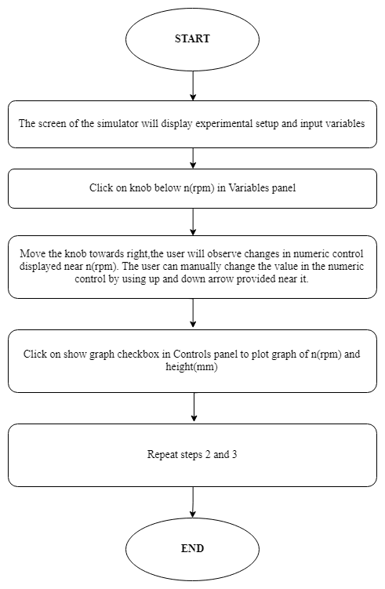

1. **Mindmap:**

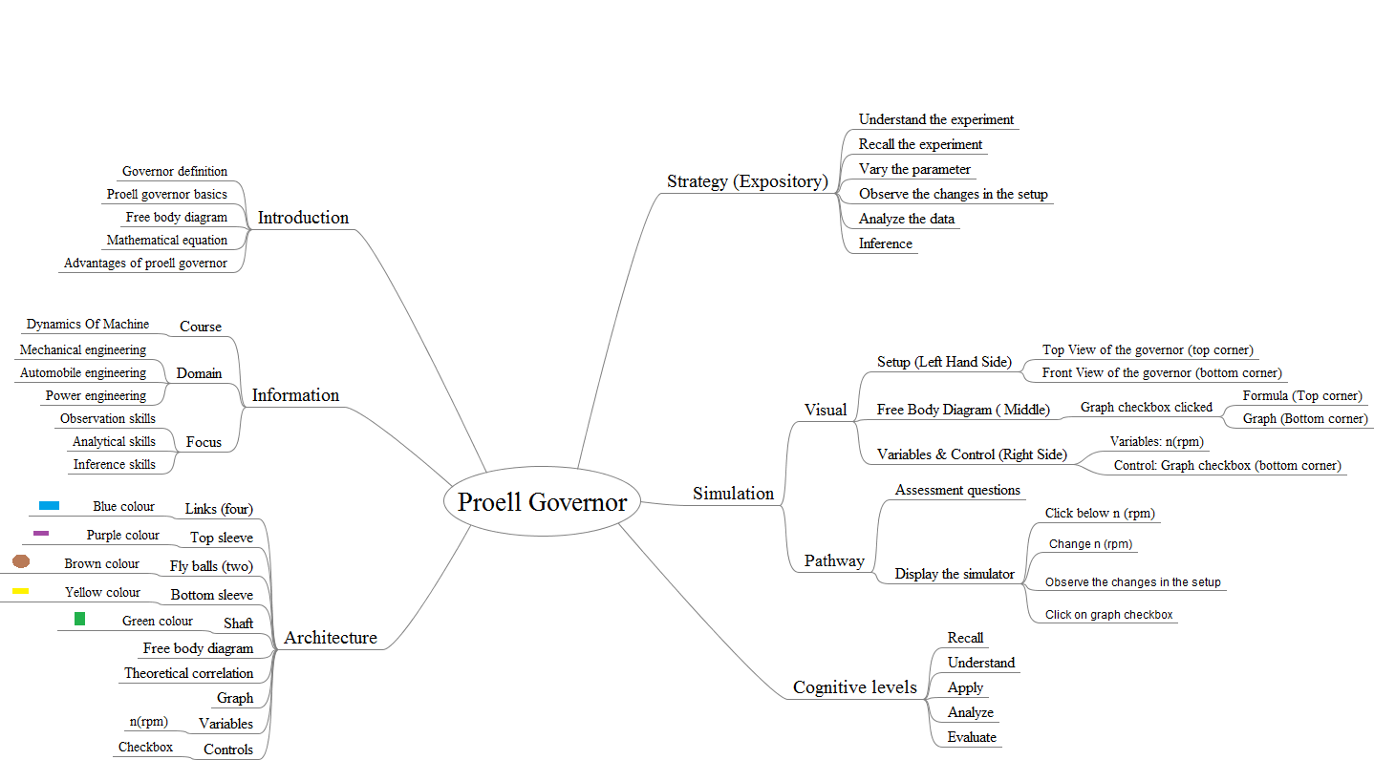

1. **Storyboard:**
   1. In simulation window front, top view and free-body diagram of Proell governor is displayed.
   2. Speed control pointer is given on top left of the screen, respective height is displayed below it and on the bottom left one checkbox for the graph is available.

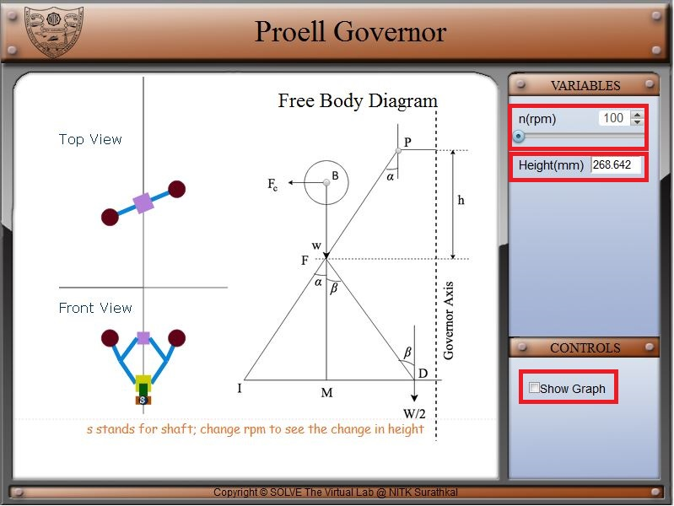

* 1. Move the slider knob to the right, this causes the rotational speed to change from 100 to 150 rpm. 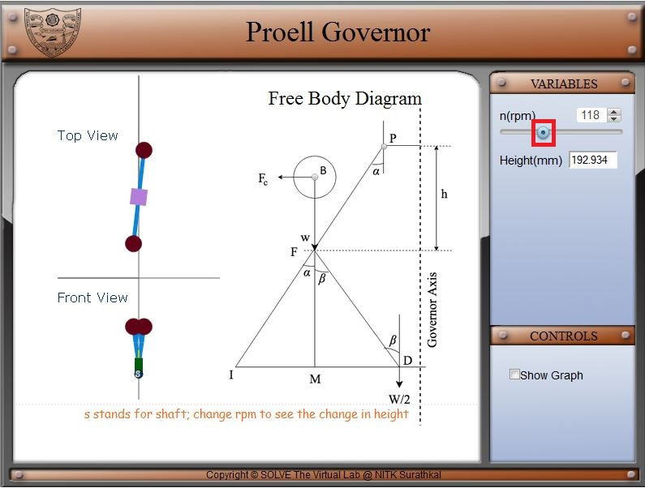

* 1. Change rotational speed from 100 to 150 rpm can be obtained by changing the arrow marks above the slider.

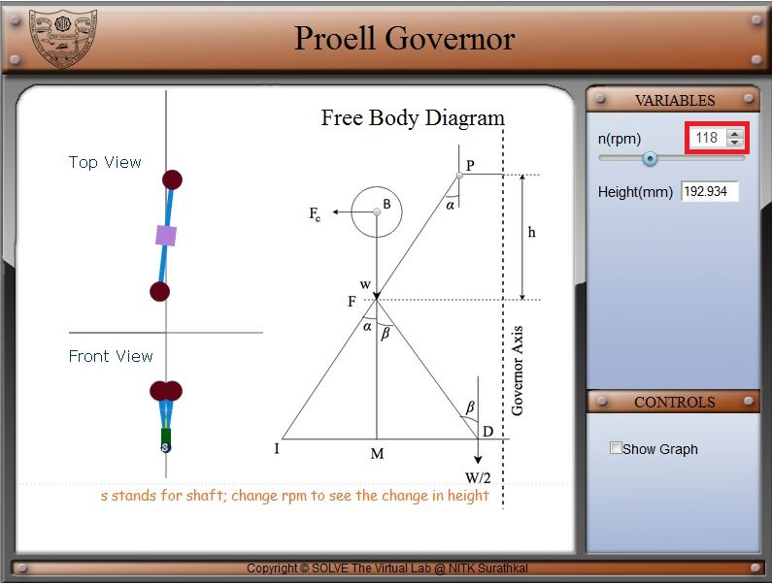

* 1. When graph checkbox is checked, a graph and theoretical correlation is displayed. This graph shows the trend of governor height on varying the rotational speed of governor.

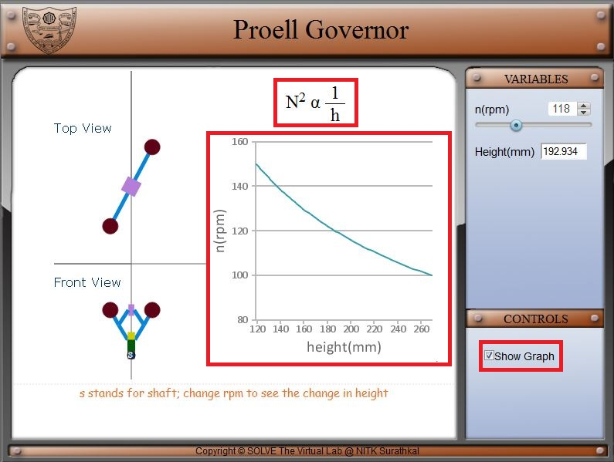

REFERENCE:

[1] <https://www.bitswgl.ac.in/lab-manuals-mech/6.KOM_DOM_LAB.PDF>

[2] Theory-of-Machines-14th-ed-Khurmi-2005 (2)